**Add a new user to the licensing process**

When a Super Admin or Admin adds a user to their license in FireFlink, and if the user has not signed up with FireFlink previously, a Set Password Link will be sent to their email address. This Set Password Link serves as a means for the user to set up their password and complete the registration process with FireFlink. By clicking on the Set Password Link in the email, the user will be directed to a page where they can create their password and activate their account. This ensures that only authorized users can access FireFlink and utilize its features.

Follow these steps to activate your account:

* The Activation Link will be sent to your email.

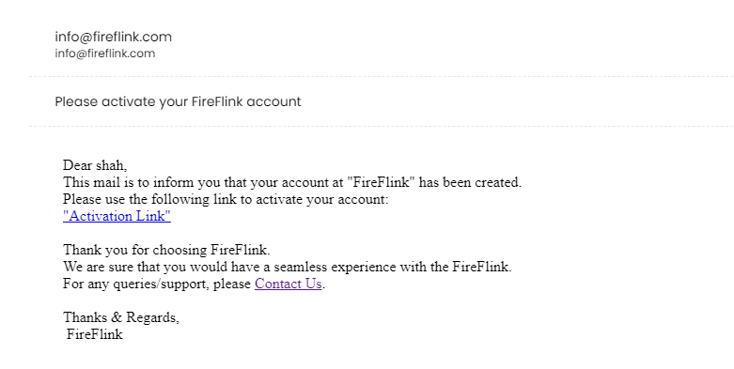

* Upon clicking on Activation Link, the user will be navigated to the **Set Password page**

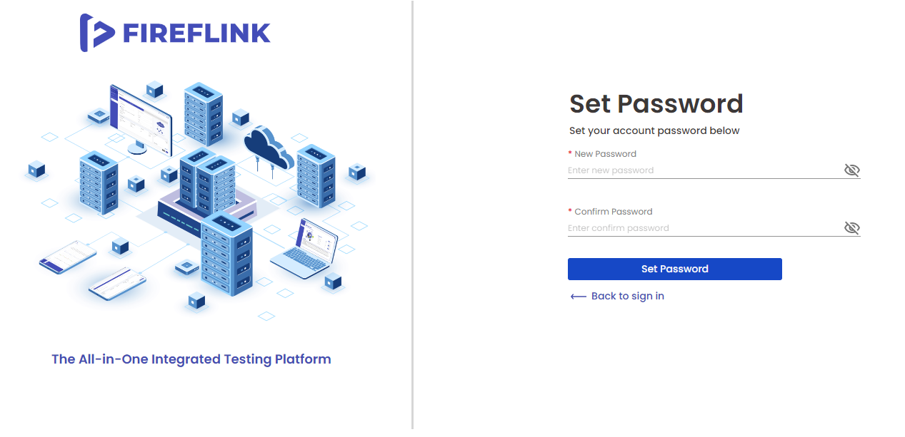

* Enter a new password in the **New Password** text field.
* Enter the confirmed password in the **Confirm** Password text field.
* Click on the **Set Password** button.
* You will get the Password Set Successfully page.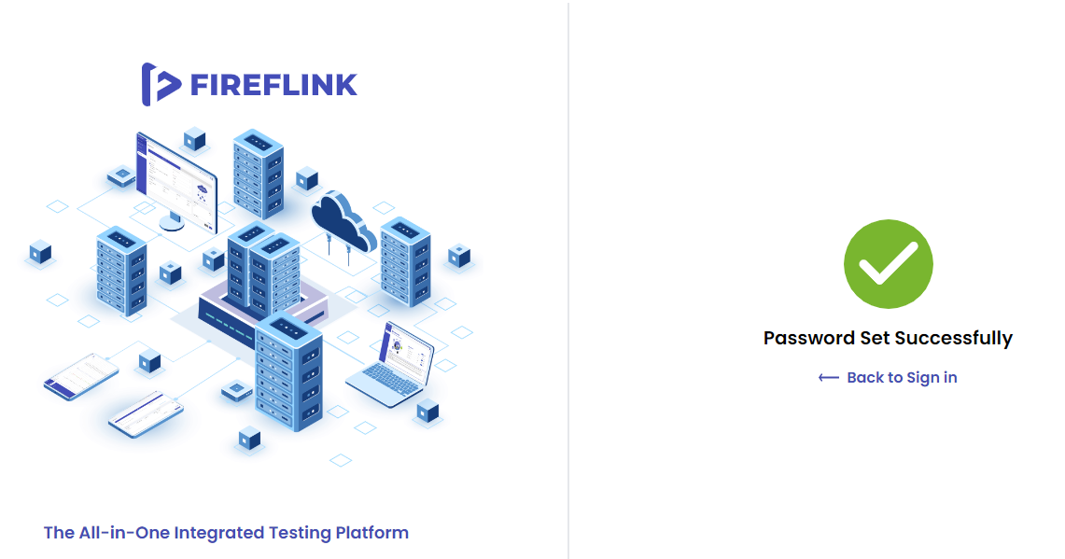
* The user will get the FireFlink Password set successfully via e-mail.
* Click on the **Back to Sign in** Link.
* You will be landed on the Sign in page.